**Q.1. Create a sample dataset and implement the below Pig commands on the same dataset.**

**a) CONCAT:**

**FILE:**

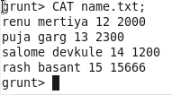

**COMMAND:**

**C:\Users\613000\Desktop\conactcmd.PNG**

**OUTPUT:**

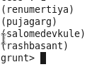

**b) TOKENIZE:**

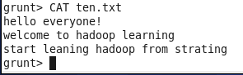

**COMMAND:**

**C:\Users\613000\Desktop\tokenizecmd.PNG**

**OUTPUT:**

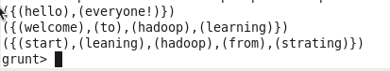

**C) SUM:**

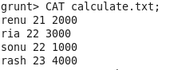

**COMMAND:**

**C:\Users\613000\Desktop\sumcmd.PNG**

**OUTPUT:**

**C:\Users\613000\Desktop\sumout.PNG**

**d) MIN:**



**COMMAND:**

**C:\Users\613000\Desktop\mincmd.PNG**

**OUTPUT:**

**C:\Users\613000\Desktop\minout.PNG**

**d) MAX:**



**COMMAND:**

**C:\Users\613000\Desktop\maxcmd.PNG**

**OUTPUT:**

**C:\Users\613000\Desktop\maxout.PNG**

**f) LIMIT:**

**COMMAND:**

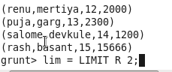

**OUTPUT:**

**C:\Users\613000\Desktop\limout.PNG**

**g) STORE:**

**COMMAND:**

**C:\Users\613000\Desktop\storecmd.PNG**

**OUTPUT:**

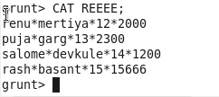

**h) DISTINCT:**

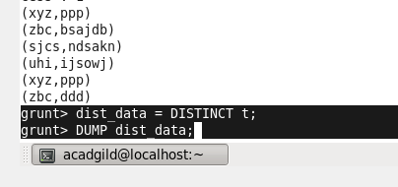

**OUTPUT:**

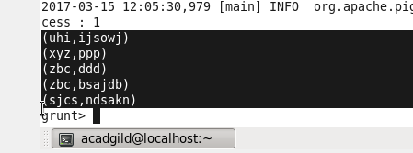

**i) FLATTEN:**



**COMMAND:**

**C:\Users\613000\Desktop\flattencmd.PNG**

**OUTPUT:**

